

Foundations of Programming

Assignment No.: 22
PROBLEM STATEMENT: Write a menu driven program in C to perform various string operations using in-built functions.

OBJECTIVE:

- To understand the concept of strings in the C programming language.
- To learn how to use built-in string functions for string manipulation.
- To perform operations such as length calculation, copying, concatenation, comparison, and reversal using menu options.
.

THEORY:
In the C programming language, a string is a sequence of characters terminated by a null character ('\0'). Strings are stored in character arrays and manipulated using functions available in the string.h header file.
Common built-in string functions include strlen() for finding the length of a string, strcpy() for copying one string to another, strcat() for concatenating two strings, and strcmp() for comparing two strings.
A menu driven program allows the user to select different operations from a list of options. Based on the user’s choice, the corresponding string function is executed. This approach makes the program interactive and easy to use.

PLATFORM: Linux

CODE:
#include <stdio.h>
#include <string.h>
int main() {
char s1[100], s2[100];
int ch;
while (1) {
printf("\n1.Length 2.Copy 3.Concat 4.Compare 5.Reverse 6.Exit\nChoice: ");
scanf("%d", &ch);
if (ch == 6) break;
printf("Enter string: ");
scanf("%s", s1);
switch (ch) {
case 1:
printf("Length: %zu\n", strlen(s1));
break;
case 2:
strcpy(s2, s1);
printf("Copied to s2: %s\n", s2);
break;
case 3:
printf("Enter string to append: ");
scanf("%s", s2);
strcat(s1, s2);
printf("Result: %s\n", s1);
break;
case 4:
printf("Enter string to compare: ");
scanf("%s", s2);
printf("Result: %s\n", strcmp(s1, s2) == 0 ? "Equal" : "Not Equal");
break;
case 5:
for(int i=0, j=strlen(s1)-1; i<j; i++, j--) {
char temp = s1[i]; s1[i] = s1[j]; s1[j] = temp;
}
printf("Reversed: %s\n", s1);
break;
default: printf("Invalid!\n");
}
}
return 0;
}

INPUT: Two strings entered by the user.

OUTPUT: Displays results of different string operations such as length, copy, concatenation, and comparison.

SAMPLE INPUT:
Enter first string: Hello
Enter second string: World
Choice: 3

SAMPLE OUTPUT:
Concatenated string: HelloWorld
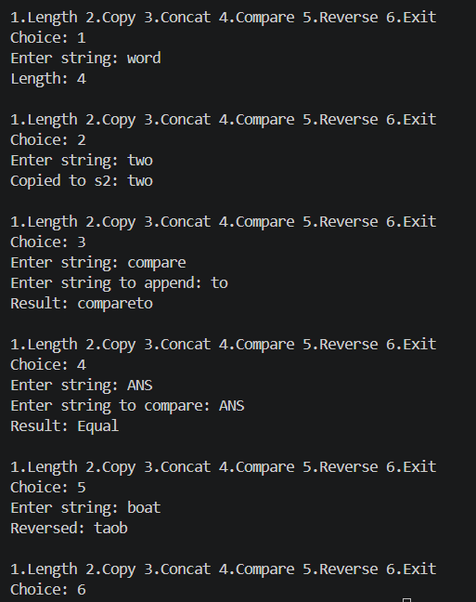
CONCLUSION: Thus, the C program successfully demonstrates different string operations using built-in functions through a menu driven approach, making the program interactive and easy to use.

FAQs:
- What are built-in string functions in C and why are they used?
- What is the purpose of the string.h header file in C programs?
- How does a menu driven program improve user interaction in programming?

